Software Requirements Specification

for

travel agency

**PACK4U  
travel agency management**

**Adane Adgo  
Tomer Handali  
Yaroslav Jirov  
Coral Avital  
Alice Aidlin  
Vladislav Kelar**

**Table of Contents**

**Table of Contents 2**

**Revision History 3**

1. Introduction 5

1.1 Purpose 5

1.2 Document Conventions 5

1.3 Intended Audience and Reading Suggestions 5

1.4 Product Scope 5

1.5 References 5

**2. Overall Description** 6

2.1 Product Perspective 6

2.2 Product Functions 6

2.2.1 Login 6

2.2.2 Register 6

2.2.3 Manger access menu 6

2.2.4 Agent menu 6

2.2.5 Client menu 6

2.2.6 Add package 6

2.2.7 Delete package 6

2.2.8 Edit package 6

2.2.9 Edit quantity of packages 6

2.2.10 Track orders 7

2.2.10.1 By client 7

2.2.10.2 By agent 7

2.2.11 Sort orders 7

2.2.11.1 By date 7

2.2.11.2 By Package date 7

2.2.11.3 By Order status 7

2.2.12 Search by category 7

2.2.12.1 By Date range 7

2.2.12.2 By Departure date 7

2.2.12.3 By Destination 7

2.2.12.4 By Price range 7

2.2.13 Order status 7

2.2.13.1 Client 7

2.2.13.2 Agent 7

### 2.2.14 Contact 7

2.2.15 Leave a feedback and rate 7

2.2.16 My orders 7

2.2.17 Popular packages 7

2.2.18 Create discount 8

2.2.19 Use discount 8

2.2.20 Message box 8

2.2.21 Send message by manager 8

2.3 User Classes and Characteristics 8

2.4 Operating Environment 8

2.5 Design and Implementation Constraints 9

2.6 User Documentation 9

2.7 Assumptions and Dependencies 9

**3. External Interface Requirements 9**

3.1 User Interfaces 9

3.2 Hardware Interfaces 9

3.3 Software Interfaces 9

3.4 Communications Interfaces 9

**4. System Features** 10

**4.1 Reserve package** 10

4.1.1 Description and Priority 10

4.1.2 Stimulus/Response Sequences 10

4.1.3 Functional Requirements 10

## 4.2 Packages Database modification 10

4.2.1 Description and Priority 10

4.2.2 Stimulus/Response Sequences 10

## 4.2.3 Functional Requirements 10

## 4.3 Login/Register 10

4.3.1 Description and Priority 10  
4.3.2 Stimulus/Response Sequence 10

4.3.3 Functional Requirements 10

## 4.4 Categorized search 11

4.4.1 Description and Priority 11

4.4.2 Stimulus/Response Sequences 11

4.4.3 Functional Requirements 11

## 4.5 Track orders 11

4.5.1 Description and Priority 11

4.5.2 Stimulus/Response Sequences 11

4.5.3 Functional Requirements 11

## 4.6 Order status 11

4.6.1 Description and Priority 11

4.6.2 Stimulus/Response Sequences 11

4.6.3 Functional Requirements 11

**4.7 Client List 11**

4.7.1 Description and Priority 11

4.7.2 Stimulus/Response Sequences 11

4.7.3 Functional Requirements 11

**4.8 Leave a message 12**

4.8.1 Description and Priority 12

4.8.2 Stimulus/Response Sequences 12

4.8.3 Functional Requirements 12

**4.9 Leave a feedback 12**

4.9.1 Description and Priority 12

4.9.2 Stimulus/Response Sequences 12

4.9.3 Functional Requirements 12

**4.10 Popular packages and feedbacks 12**

4.10.1 Description and Priority 12

4.10.2 Stimulus/Response Sequences 12

4.10.3 Functional Requirements 12

**4.11 Discount offers** 12

4.11.1 Description and Priority 12

4.11.2 Stimulus/Response Sequences 13

4.11.3 Functional Requirements 13

**4.12 Manager access** 13

4.12.1 Description and Priority 13

4.12.2 Stimulus/Response Sequences 13

4.12.3 Functional Requirements 13  
**4.13 Messages Box** 13

4.13.1 Description and Priority 13

4.13.2 Stimulus/Response Sequences 13

4.13.3 Functional Requirements 13

**5. Other Nonfunctional Requirements 14**

5.1 Performance Requirements 14

5.2 Safety Requirements 14

5.3 Security Requirements 14

5.4 Software Quality Attributes 14

5.5 Business Rules 14

**6. Other Requirements** 14

**Appendix A: Glossary** 14

**Appendix B: Analysis Models 15**

**Appendix C: To Be Determined List** 15

**Revision History**

|  |  |  |  |
| --- | --- | --- | --- |
| **Name** | **Date** | **Reason For Changes** | **Version** |
| Team2 | 9.12.20 | Failed to achieve expectations and little fixes to design. Updated | 1.1 |

# 

# 1.Introduction

## Purpose

The purpose of this document is to provide a detailed overview of our software product and to describe the project requirements that we provided with by the client in order to ensure that the software we produce will be consistent with need of our client.

## Document Conventions

The software will be written in CPP using visual studio*.*

The database will be managed with encrypted files

## Intended Audience and Reading Suggestions

The intended audience of this document consists of clients, travel agencies, development team, managers, and the project supervisor, before reading this document it is highly recommended to read the Vision Document to get an overview of the product.

## Product Scope

The software will facilitate user interaction with the database by providing a customized management system for company data, travel agents will have an efficient and orderly way of managing packages and tracking bookings. Customers will have an easy and wide functional user experience, including contacting travel agents, search and flight packages, and managing their bookings. The manager will have all the agent options as well as access to the agent accounts and the ability to add/remove agent accounts.

## References

SRS template.

# Overall Description

## Product Perspective

In the past, a client had to contact an agency to book his vacation and this usually requires a lot of time and effort without the ability to easily track and cancel bookings. With our product users provide a user-friendly interface through which they can interact with the system, the software helps customers and agents record search results, process orders, modify and cancel existing orders. As well as help managers keep track of their agents.

## Product Functions

**2.2.1 Login**

A function that receives username and password to identify the user using the DB and Then send the user his relevant menu.

**2.2.2 Register**

### A function that gets a username, password, and ID, and creates a user-type client or agent depend on the user and adds it to the DB.

### 2.2.3Manger access menu

A menu which is customized to the manager's capabilities, includes all the agent's features and the ability to add / remove agents and activate the mailing list to agents, in addition to generating a coupon code that will be a discount for packages that the user will want to purchase.

### 2.2.4Agent menu

A menu for the agent customized according to his abilities, edit a package, edit the package database, approve packages purchased by customers, correspond with customers and manager and change package details in the database.

### 2.2.5 Client menu

A menu for the customer customized according to his abilities. Who place an order, display the order history, the order in the process and the ability to cancel an order, in addition the option to send a request and receive a messages from the company about new deals.

**2.2.6 Add package**

The travel agent will have the ability to create a new package according to the company offers and add it to packages DB.

### 2.2.7 Delete package

The travel agent will have the ability to remove a package from the data base. And deny her further access from the DB.

### 2.2.8 Edit package

The travel agent will have the option to edit the package details, change fields such as flight dates, destination hotels, etc.

**2.2.9 Edit quantity of packages**using the edit function, by adding the same package but changing the quantity of it.

**2.2.10 Track orders**

**User will be able to see purchase date, package date and order status there 2 type of access:**

### 2.2.10.1 By client

Clients can track only their private orders, rate closed orders, view open orders, and "in-process" packages, and cancel orders.

**2.2.10.2 By agent**

Agents can track their sales orders, by selecting a customer from a DB agent who can view the same action as the customer can and confirm an order placed by the customers.

**2.2.11 Sort orders**

A function that sorts the orders list by the following criteria:

**2.2.11.1 By date**

Sort the list by the date the order was made.  
**2.2.11.2 By Package destination**

Sort and view package by the wanted destination only  
**2.2.11.3 By Order status**The agent will be able to look for specific type of status orders – processing, approved, cancelled.

### 2.2.12 Search by category

### Ability to search and view packages by the following categories:

**2.2.12.1 By Date range**sort andReturn the packages by given range of dates, and sort and view the wanted packages  
**2.2.12.2** **By Departure date**sort andreturn all the packages fit to the user the package of departure date he wanted

### 2.2.12.3 By Destination sort and return all the packages including the given destination by the user 2.2.12.4 By Price range sort and return list by price ranges – all the prices that fit

**2.2.13 Order status**change the status of order (approved, in processes and cancel)

### 2.2.13.1 Agent

### The travel agent will have the ability to approve a processing order or cancel it for a client from the DB, he will also contact a client with a “in process” order

### 2.2.13.2 Client

### The client will have the ability to cancel an order, by exiting a in processes order he will create a package with “in process” status.

### 2.2.14 Contact

### The user can leave a message with his details to the agents, to get details about anything from the company, the message can be free style text.

### 2.2.15 Leave a feedback and rate an option to clients with closed orders who use there package only, the client will be able to rate the package on a scale from 0-5 stars and leave a free text describing their experience.

**2.2.16 My orders**a function that add new orders that made by client, the client can watch his orders.

**2.2.17 Popular packages**a feature for the use on any user which present the most popular package, package get into the list of poplar package by calculating the selling and the ratings.

**2.2.18 Create discount**A function to the use of the manager that can create a “discount gift” with number of precents off according to the manager will, to for any event by delivering a code

**2.2.19 Use discount**In order to activate the discount, clients will receive a coupon code in their message box, which the need to activate in the payment process

**2.2.20 Message box**Users will be able to see general messages from the company, for example responses to their requests or discount offers. Agents will receive an instruction from manager

**2.2.21 Send message by manager**the manger is the only user of this featureThe manger will have the ability to add message to the clients messages list.

**2.3 User Classes and Characteristics**

There will be four kinds of user classes: Manager, Agent, Client, and Visitor. Aside from having the agent's characteristics, the manager will have access to the agent database where he will be able to add/remove agents and contact them. The agent will have access to all the software features regarding client and package management, whether it is editing package details or approving processing orders. The client will have a more limited number of features in terms of access to the database. The client will be able to view packages, order, and contact travel agents. Lastly, there is the visitor, who will be able to search and view packages but will not be able to make an order until they are registered.

## Operating Environment

The system runs on Microsoft Windows 7/8/10 versions 86x and 64 bits.

OK design and employment construct the company must.

## Design and Implementation Constraints The company must have a large enough storage highly recommended in a cloud. In addition the company will need computers that will run the software.

## User Documentation

The user will receive an instruction manual detailing the functionality of the software.

The client can contact our service department via mail with the possibility of receiving a personal guide.

## Assumptions and Dependencies

Our assumption is that the employee pool will be obtained from the human resources department in a .txt file where the program will assign 'login' details of all the company's agents.

The file will be as follows: ID, full name, email, password.

The database includes access information for each user such as an employee and manager specified by the job.

The system assumes that when the payment details are valid, the transaction is approved.

# External Interface Requirements

## User Interfaces

The software is console designed, each user will have his adapted menu, according to the following type of user manager, agent, client and visitor, User will have to use a keyboard in order to navigate between options.

the full menus will be described in the protype.

## Hardware Interfaces

The application requires a monitor and working computer with OS installed including a keyboard.

## Software Interfaces

The application will have access to the data base that was written by a third-party software program (in a .txt format) and connect with the clearing system the interface is as shown in the prototype.

## Communications Interfaces

Communication with human resources databases for data transfer to the software.

In addition to communicating with managers to add improvements, external factors like the clearing/payment system.

# System Features

## 4.1Login/Register

**4.1.1 Description and Priority**Every user will have a username and password in the DB and the system will automatically identify the type of the user and will send him a suitable menu. Only registered users will have access to interaction and personal features such as making/viewing orders. Unregistered users will have to create an account and enter their personal details to access the features of registered clients.

**4.1.2 Stimulus/Response Sequence**  
From the home page the user can select the login/register option. Users who already have an account will select login and then enter their username and password. Visitors who are yet to create an account will need to select register and enter their personal details. The system will recognize the type of the user and will send him to the right menu.

**4.3.3 Functional Requirements**REQ-1: To login, username and password must exist in the DB.

REQ-2: User will have to type the password correctly – password is case sensitive

## 4.2 Make an order

**4.2.1 Description and Priority**The top priority feature will allow to the client to book a vacation according to his will,  
by choosing out of the agency packages list which includes flights, hotels, and vacations.

**4.2.2 Stimulus/Response Sequences**  
The client will choses a package out of the list by clicking “book it”. Then a registered/login window will pop up in case the user yet to be logged in. After that, the user will be moved to the summary page and finally to the payment page.

**4.2.3 Functional Requirements**REQ-1: User must be logged in, otherwise the access to the reservation will not be available

REQ-2: The availability of the package needs to be updated all the time.

REQ-3: The company must have a connection to payment system.

## 4.3 Track orders

**4.3.1 Description and Priority**The user will have the ability to view orders made and its details including: status, order date and package date. That way the user can see the order's details at any time.

**4.3.2 Stimulus/Response Sequences**  
Agent/manager will have to click on “view clients” choose a client than click on “track orders”. The client will have “my orders” option in his menu there he can see his orders and their status.

**4.3.3 Functional Requirements**REQ-1: There must be existing orders

REQ-2: Client can view only his orders, only agent can view all clients' order.

## 4.4 view packages

**4.4.1 Description and Priority**The user will have the option to search for a package according to the following categories: destination, price range, dates, or a combination of all.

**4.4.2 Stimulus/Response Sequences**  
After the user clicks “search packages” they will have to fill their demands.

**4.4.3 Functional Requirements**REQ-1: Valid date - otherwise the user will have to fill the date again.

REQ-2: Non - negative price range – otherwise the user will have to fill it again

## 4.5 Edit Packages

**4.5.1 Description and Priority**The agents will be able to modify the list of the packages the travel agency offers by adding, editing and deleting packages from the database. To keep the database updated always.

**4.5.2 Stimulus/Response Sequences**  
After the system recognized the agent/manager the user will choose the “view packages” option. Then he will have to click on the edit or add/remove. From there he will have access to the database.

**4.5.3 Functional Requirements**REQ-1: Only agent/manager type of user will have the access to this feature

REQ-2: The package edit/add must be time valid and according to given format ***

## 4.6 Messenger

**4.6.1 Description and Priority**The agents and the clients will have a messages box; the agents will receive a general notification from the agency management and the clients will get notification about discount offers.

**4.6.2 Stimulus/Response Sequences**  
After the user is logged in, he will see a notification for any new messages next to "my messages" option. By selecting it he will be able to view the messages window.

**4.6.3 Functional Requirements**REQ-1: The user must be logged in.

REQ-2: Only the manager will be able to send messages.

## 4.7 package review

**4.7.1 Description and Priority**After package been used the user will have the ability to rate the package (0-5) stars, when 5 is the highest score meaning the client enjoyed. The user will be able to write a short comment explaining their rating choice. This feature will assist other clients track the best packages.

**4.7.2 Stimulus/Response Sequences**  
After client get logged, he will choose the “my orders” option and choose a used package. Then he will have the option to leave his feedback.

**4.7.3 Functional Requirements**REQ-1: Client must be logged in.  
REQ-2: Client will have to leave a message.  
REQ-3: Client will have to choose a used package

## 4.8 Coupon maker

**4.8.1 Description and Priority**The system will give the manger the ability to send a message with the discount code to the clients list from the DB, and then the client will be able to activate the discount at the order.

**4.8.2 Stimulus/Response Sequences**  
A user will receive a message from the system with the discount code and then at ordering processes he will be able to activate it.

**4.8.3 Functional Requirements**REQ-1: Client code must be valid and not expired and case sensitive

REQ-2: The manger will have filled the discount details properly

## 4.9 Popular packages and feedbacks

**4.9.1 Description and Priority**Before choosing a package the user will have the ability to view most popular packages sorted by feedbacks and view other client’s comments and suggestions.

**4.9.2 Stimulus/Response Sequences**  
After choosing the “view packages” option the user will have to choose “show me poplar packages” and after choosing a package he can click on show me reviews.

**4.9.3 Functional Requirements**REQ-1: “popular” packages must exist.

**4.7 Client List**

**4.7.1 Description and Priority**

This feature will assist the agents and managers to track and manage their clients and will be used to view the client's orders and their status.

**4.7.2 Stimulus/Response Sequences**

The user will select "View clients" option on the interaction menu and a list with the different clients and options will be shown.

**4.7.3 Functional Requirements**

REQ-1**:** The user needs to be an agent/manager to access this list

## 4.10 Leave a message

**4.10.1 Description and Priority**The user will have the ability to leave a message to contact an agent for asking questions and make requests. The user's details will be noted in the message.

**4.10.2 Stimulus/Response Sequences**  
After the client logged in and got to the menu he will have to click “contact us” and then leave his message.

**4.10.3 Functional Requirements**REQ-1: Client must be logged in

## 4.11 Manager access

**4.11.1 Description and Priority**For highly operations of the system there will be a unique user who can modify the agents list, send messages and discounts offers. Manager can do anything an agent can do.

**4.11.2 Stimulus/Response Sequences**  
When a manager has logged in the system will recognize him automatically and send him to his menu.

**4.11.3 Functional Requirements**REQ-1: Manager account must exist

REQ-2: Details must be valid

**4.12 Order status**

**4.12.1 Description and Priority**

The user will be able to change order status. The agent will be able to approve processing orders or cancel them while the client will only be able to cancel in case anything irregular happens.

**4.12.2 Stimulus/Response Sequences**

The user will use the tracking orders feature to find the order he wishes to change status for. There he will be able to do so.

**4.12.3 Functional Requirements**

REQ-1: The order must exist to change its status.

REQ-2: You must be an agent to approve a processing order.

**4.6 Order status**

**4.6.1 Description and Priority**

The user will be able to change order status. The agent will be able to approve processing orders or cancel them while the client will only be able to cancel in case anything irregular happens.

**4.6.2 Stimulus/Response Sequences**

The user will use the tracking orders feature to find the order he wishes to change status for. There he will be able to do so.

**4.6.3 Functional Requirements**

REQ-1: The order must exist to change its status.

REQ-2: You must be an agent to approve a processing order.

# Other Nonfunctional Requirements

## Performance Requirements

The system must be linked with internal big enough storage to save the database files, and also must be linked with clearing system to make the payments time of running depending on the client ram and may differ from pc to pc.

## Safety Requirements

we recommend the company to back up their files in case of loss of access to their company pcs, in case the system will crash by External disturbances all company closed transition will be saved and any in-process operation will be deleted.

## Security Requirements

The main security feature to secure the system from outside users is the user name and the password any user gets which they may not be transferred, system files we are locked, files will be encrypted to avoid personal info leaked.

## Software Quality Attributes

* The product will be available to every agent of the travel agency company.
* The product is easy to use.
* The software is compact.
* The software is reliable and has updated bug fixes.

## Business Rules

* Only a travel agent can change the prices and accesses to all the available packages.
* The client has no ability to access other customer's details and will only be able to see his details and orders.
* Only the manger can run the mailing list, and send the general messages

# Other Requirements

## Appendix A: Glossary

* SRS – Software Requirements Specification
* OS – Operating System
* HR – Human Resources
* RAM – Random Access Memory
* SQL – Struct Query Language
* CPP
* TBD – To Be Defined

**Appendix B: Analysis Models**

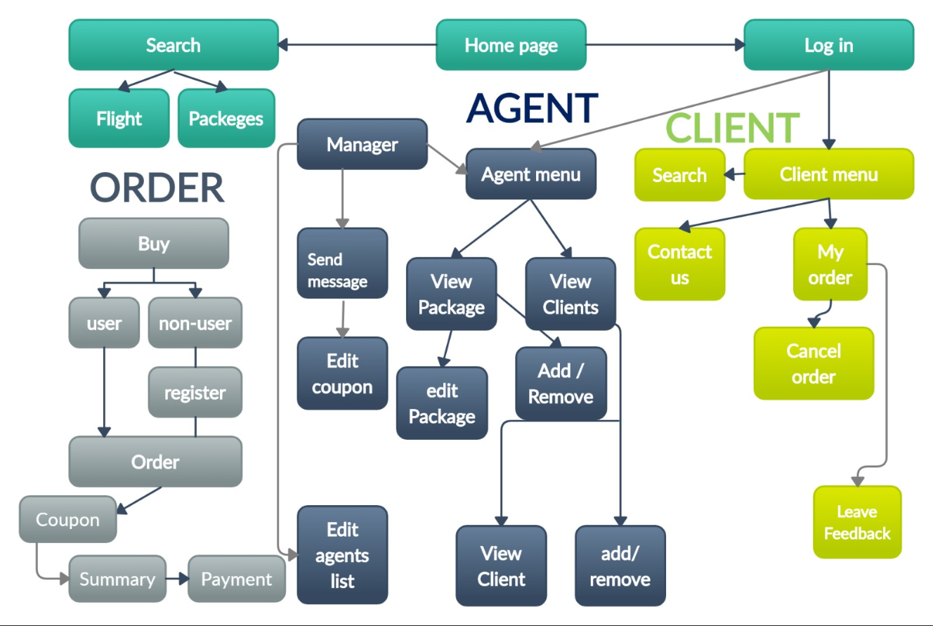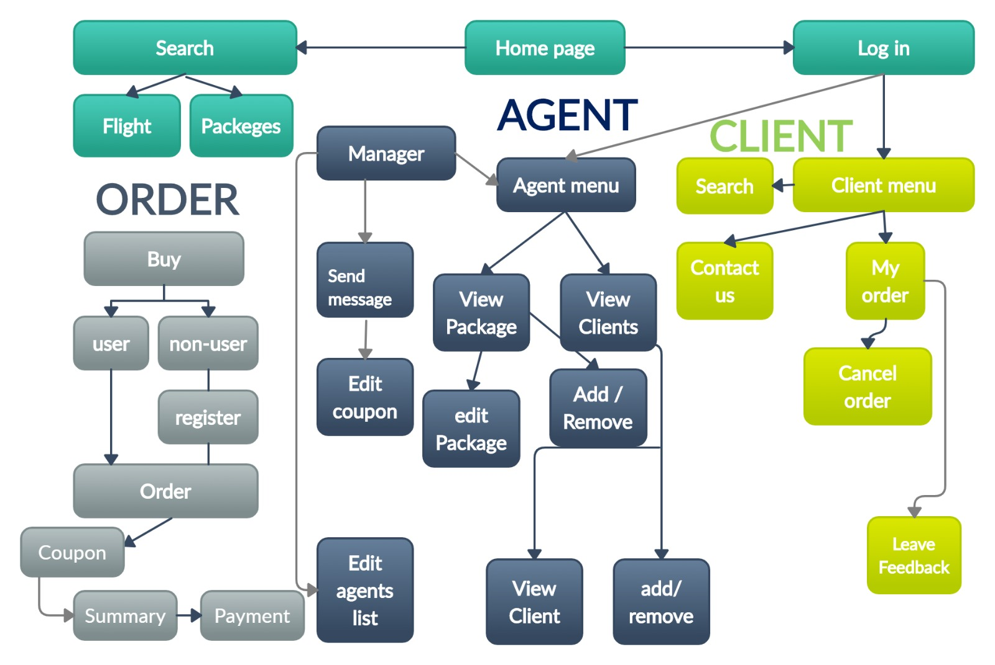

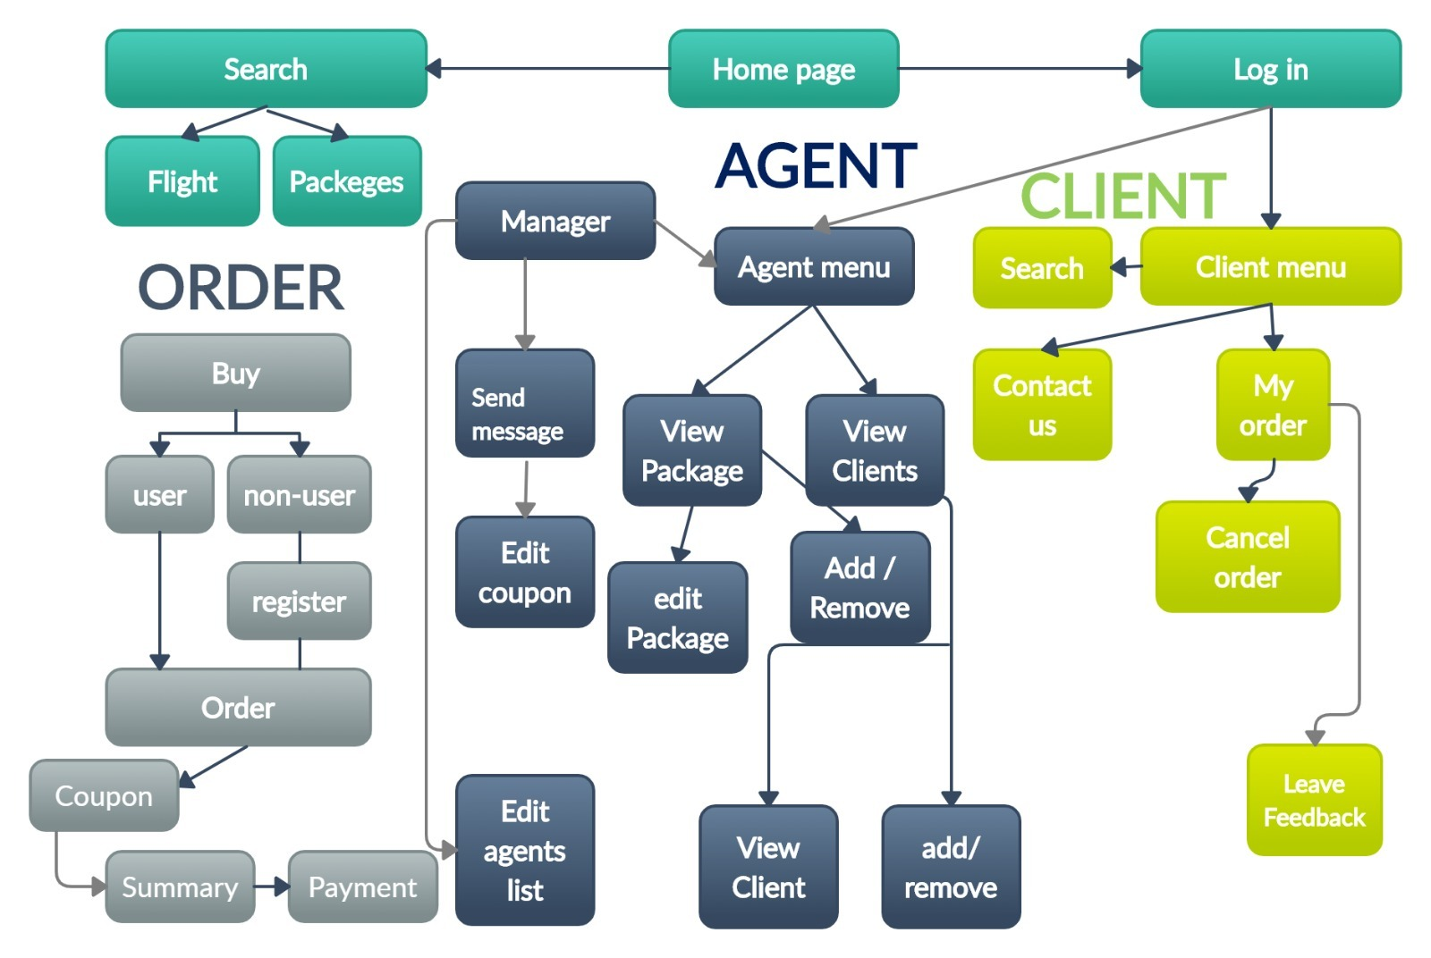

**Appendix C: To Be Determined List**

* SQL

